ELEC 2210 LABORATORY REPORT COVER PAGE

Complete and attach this page to the front of your lab report.

Meeting # 002 EXPERIMENT 3: Medium Scale Integrated (MSI) Circuits *Title of Lab Experiment*

Student Name: Howard Jacob, A

*Name (Last, First, MI)*

Student Email: JAH0147

*AU 7-character username*

GTA: Jonathan

*Name of your GTA*

The section you are enrolled in: (Circle One): 1 2 3 4 5 6 7 8

Date experiment performed (dd / mm / yy): 9/9/20

Date report submitted: (dd / mm / yy): 15/9/20

If you performed this experiment at a time other than your regularly scheduled section meeting:

Section # of the section you sat in on (Circle One): 1 2 3 4 5 6 7 8 Makeup

Name of the GTA who supervised your work: None

I hereby certify that the contents of this report are true and complete to the best of my ability. The lab work was performed by me exclusively, and this report was written by me exclusively.

Jacob Howard 9/9/20

Student signature Date signed

ELEC-2210

Digital Electronics

FROM: Jacob Howard

TO: Jonathan

DATE: 9/9/20

LAB SECTION: 002 (Tuesday, 1:00pm-2:50 pm)

EXPERIMENT 4:

Binary Arithmetic Circuits

# **Introduction**

# For this lab, we reviewed and a real life application to some of the binary topics from Digital Logic Circuit. We learned how to use this binary numbers, apply any time of arithmetic to them and apply that to a functioning circuit. In addition to this, we learned how to connect LEDs to a CMOS output.

# **Step 1**

This lab concisted of two parts. These two were not dependent on each other, but they still were related. In the first part we built a 4-bit adder and tested the results obtained. This testing was achieved by comparing the results obtained in the ELVIS’s LEDs and the results obtained by our hand-made arithmetics. We started by connecting a CD74ACT283E(4-bit adder) to a 74161(counter). The adder will get the sum of the input numbers from the counter. The remaining input numbers would be obtained from the diodes 3-0 that were manually inputted using the Digital Writer. Same as the second group of inputs, the carry-in value was also given by the Digital Writer using the Diode 4. All the proper connections were obtained from our previous work done for the pre-lab. The outputs of the adder would be shown in 4 of the ELVIS LEDs while the carry-out would be displayed with an external LED/resistor combination. In my instance, I always had LED 0 on for some reason. I must have had a slight error when wiring the circuit. This caused some issue with not being able to finish the Lab, but Table 1 shows what the correct output should be.

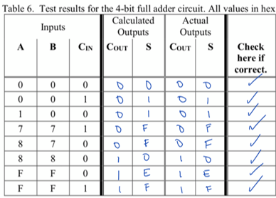

*Table 1*

# **Step 2**

For step 2 of the lab, we did not have a need for many of the components from part 1, exept for the LED and the 220 Ohm resistor. We were asked to measure the voltages across the resistor and the LED. I did not get to this part of the lab, so I did not get the data myself. The data below was observed by one of my peers shown in Table 2

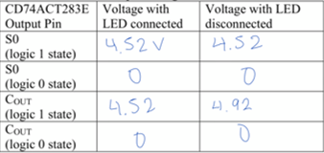

*Table 2*

# **Conclusion**

This experiment was a very interesting look at how real life adders work. By using different chips and components, we were able to see how simple arithmetic can be done with LEDs in a binary manner. Although this lab was slightly more difficult to me, I did really enjoy it and it was very interesting to me.